AI Lab 05 Submission

Name: Yash Raj
Roll Number: 24k-0737

Task 01:
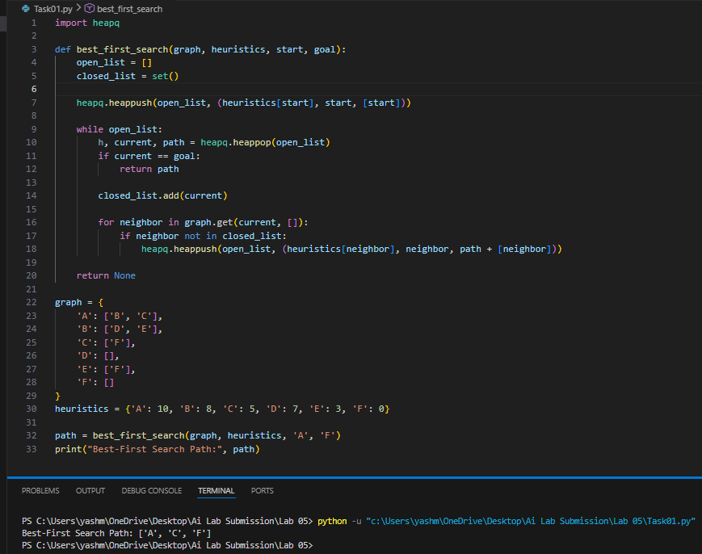

Task 02:
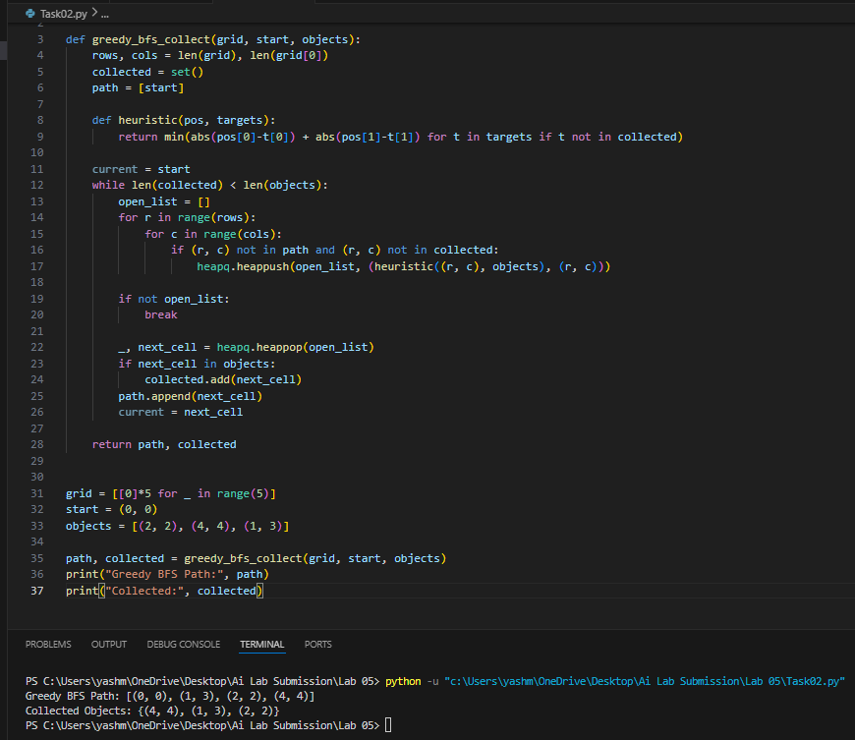

Task 03:
